The steps are as follows.

1) Download Fiji for image J

<https://imagej.net/Fiji/Downloads>

 The user guides are found here

https://imagej.net/User_Guides

2) Access the images on the drive

https://drive.google.com/drive/folders/1qJJnMB4CVinA_7v4ZGbgEUxNzGj8F1ZG?usp=sharing

3) Download a folder with a date to your computer

4) From Fiji/Image J select the image

File 🡪 Open 🡪 select the image you will process

5) Select the straight-line tool and measure the white tag at the base, the part closest to the tray. Make sure it is as parallel to the top of the tag as possible to ensure the most accurate measurement.

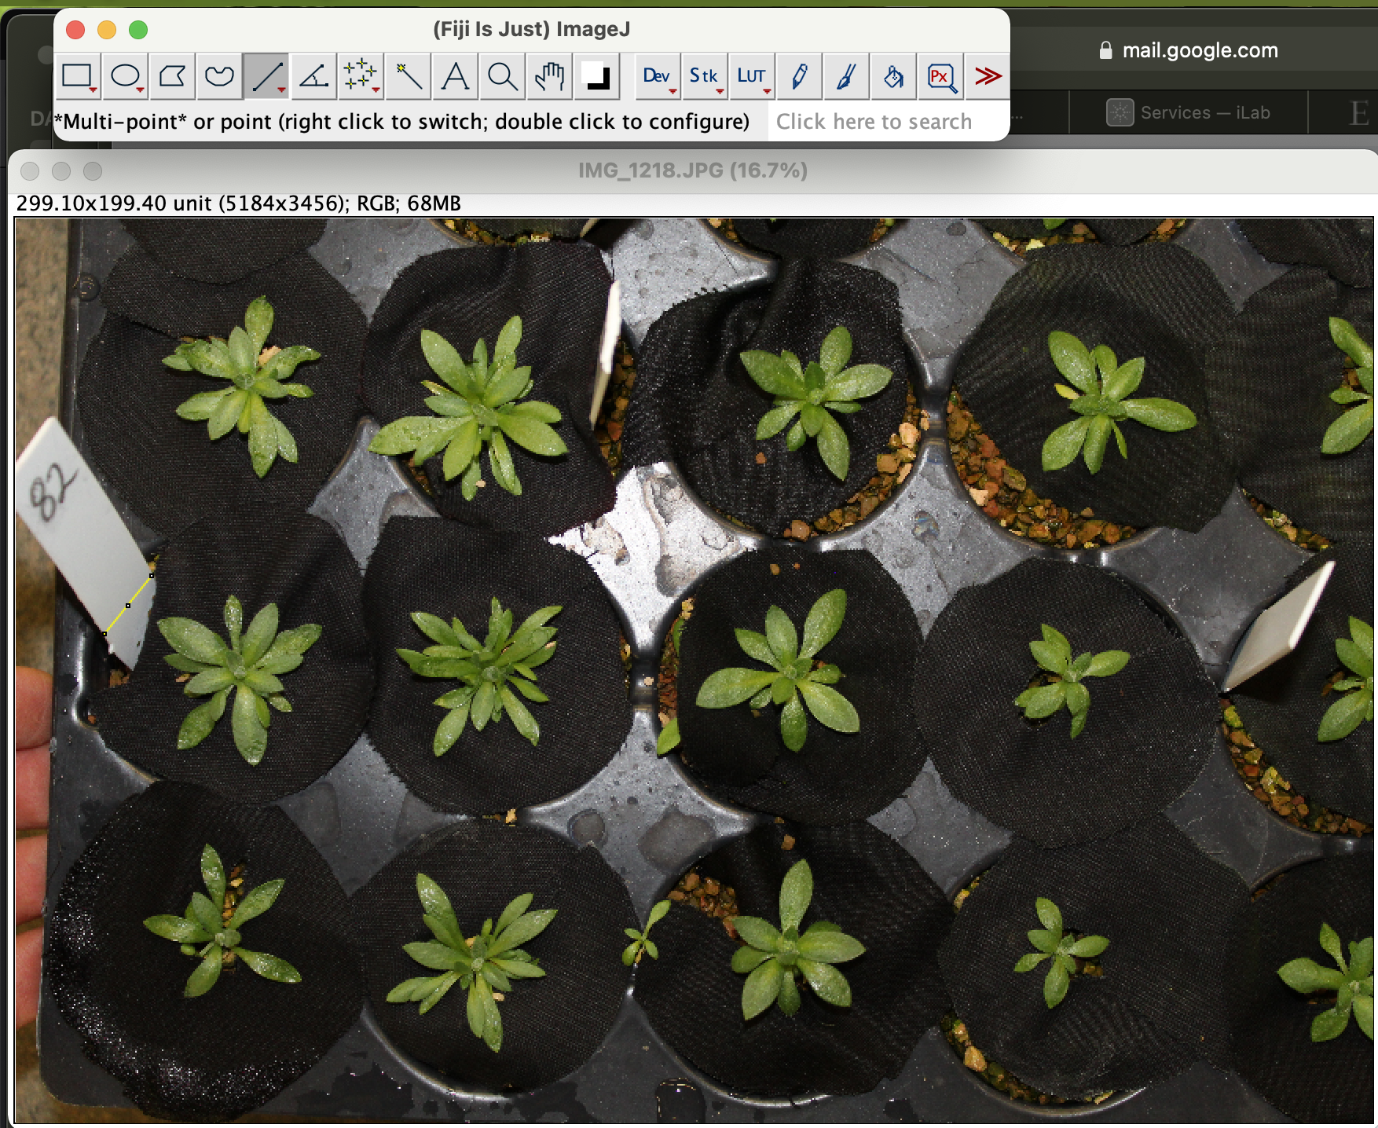

6) Then click analysis and set scale (width of the tag is 16.49 mm). And fill out the number of pixels for that segment. On the excel sheet. Along with the quadrant number that is in the tag on the top left of the image and the image number (82 in this example) to increase our accuracy if you measured it three times and record pixel counts/pixels per unit (our units are mm), to do this you would remove the scale and then re-draw the line. I have made columns for the repeated measurements and then there is a final column (pixels per unit avg) that will calculate the average – this is the number I will use for the pixel counts per plant to calculate their above ground growth rate!

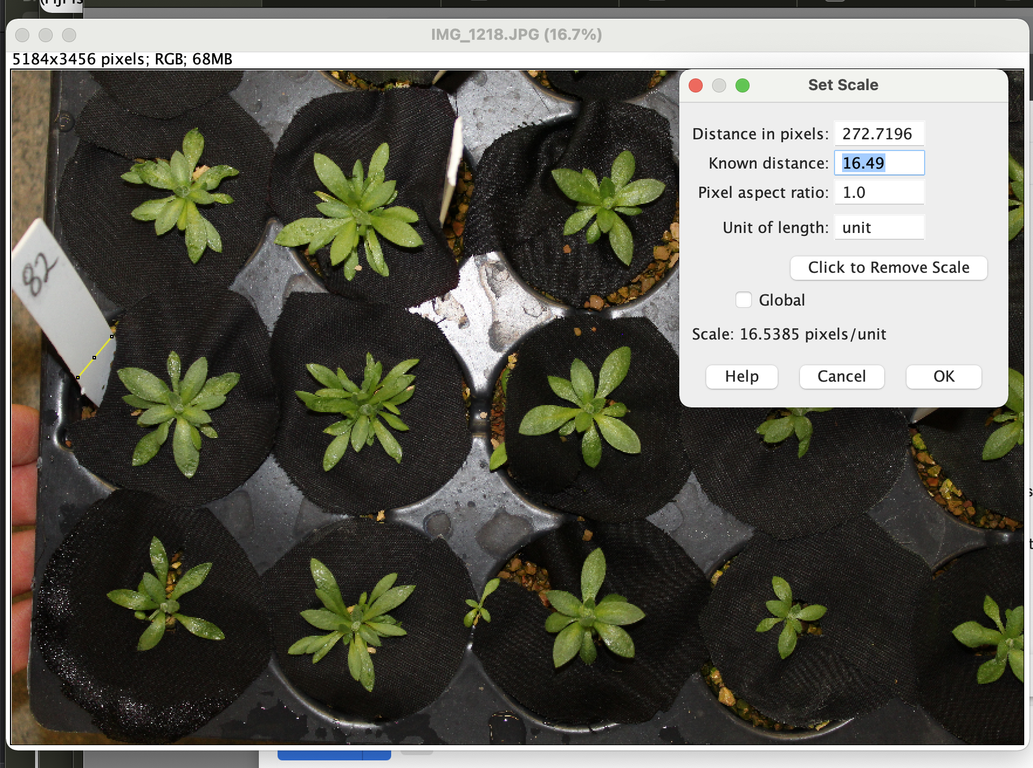

7)Then you can do file 🡪 close to close the current image and then move on to the next. You don’t need to save the changes unless you want to. Once you have made it through the images in the folder you can delete that folder from your computer and download the next one.

8) Remember to reach out any time if there are any images that you are confused about!! I am very happy to have you on board with this project and will love hearing from you ☺